**CLINIC MANAGEMENT SYSTEM**

Team Name: Five Stars

Team Members:Binu Christin, Dhanya Krishnan, Praveena VM, Sajitha, and Leema

Date of Activity: 10th Dec 2021

Heading: Clinical System

Actor Catalog:

Administrator :-

Manages the staff details and medicine details.

Receptionist :-

Staff in the front desk manages all the operations related to the registration of the patient and appointment schedule.

Doctor :-

Doctor prescribe medicines and add doctor notes to the profile of the scheduled patients.

Pharmacist :-

Pharmacist generate bills for the prescribed medicines.

Lab technician :-

Lab technician generate and update the test results.

**Use case Catalog :**

**Admin**:

*Add the different users to the system and add services to the users

*Edit services

*Edit doctor details

*Edit patient details

**Receptionist:**

*Schedule patient hospital admission

*Patient registration

*File insurance forms /claims

*File medical report

*Out/In-patient hospital admission

*Bed allotment

**Doctor:**

*Check appointments

*Check the patient's health information

*Check the patient's test reports

*Takes doctor notes

*Prescribes the medicines.

**Lab Technician:**

* Generates the test results.

* Updates the results based on the prescription given by the doctor.

* Interprets the results and provides alternatives for the treatment.

* Generates the bill based on the tests.

**Pharmacist:**

*Search Medicine data for the prescription.

*Check whether the prescribed medicine is available.

*Generate the medical bill.

*Update, delete, and Edit medicine information.

**Use case elaboration**

**ADMIN**

| **USE CASE TEMPLATE** | | |
| --- | --- | --- |
| Edited By |  | Leema Pereira |
| Properties |  | Description (Role of an Admin) |
| Use case No. |  | 1 |
| Use case |  | 1. The admin signs in to add new staff information. |
| Pre-condition |  | 1. Admin should log into the system and check whether the staff to be added is already existing or not. |
|  |  | 2. All details to be entered must be known to the admin |
|  |  |  |
| Normal Flow |  | Supervise daily administrative operations |
|  |  | 1. Choose the option to add a new staff |
|  |  | 2. Add staff's details like name, contact details, designation,salary,schedule. |
|  |  | 3. Register the staff |
|  |  |  |
| Alternate Flow |  | 1. If staff already exists choose the option to view the entered details and check all the details. |
|  |  | 2. If staff is no more in service, disable the relevant account. |
| Input |  | Name, contact details of the staff, login credentials of the staff, login credentials of the admin. |
| Validations |  |  |
|  |  | 1. Credentials must be exclusive to the admin and admin should get a notification if a new staff is registered successfully. |
|  |  | 2. All details must satisfy the requirements |
|  |  |  |

**DOCTOR**

| EDITED BY | SAJITHA S |
| --- | --- |
| PROPERTIES | DESCRIPTION |
| USE CASE NO | 1 |
| USE CASE | Doctor check the previous visit,medicine  prescription,lab test result,doctor notes of the patient |
| PRE  CONDITION | 1.Doctor should login to the system and enter the patient id |
| NORMAL  FLOW | 1.Choose the option to search the patient id  2.Select that particular patient  3.Check the previous date of admission  4.check the test results, if any  5.check the previous prescribed medicines |
| ALTERNATE  FLOW | If that detail does not exist, create a new one with that patient. |
| INPUT | Patient id,patient name, date of visit |
| VALIDATIONS | 1. While entering the patient id it should be valid . 2. Display a message that entered patient id matched. 3. Check the availability of all the details like date of admission, disease, lab test results, previous medicine…. |

**RECEPTIONIST**

| Edited by | Dhanya Krishnan. S |
| --- | --- |
| Properties | Description |
| Use case No. | 1 |
| Use case | Receptionist adding new patient details/ new patient registration |
| Pre-condition | Receptionist should login to the system and check whether the patient added is already existing or not |
| Normal Flow | 1. Choose the option to add new patient  2. Add patient details like Name, age, Phone number, Address, Blood group etc.  3. Register the patient. |
| Alternate flow | If patient already exists choose the option to view and check all the details |
| Input | Name, age, Contact number, Address, Blood group, Marital status |

**PHARMACIST**

| EDITED BY | PRAVEENA.V.M |
| --- | --- |
| PROPERTIES | Description |
| USE CASE.NO | 1 |
| USE CASE | The Pharmacist Search Medicine based on the prescription. |
| PRE-CONDITION | Check the availability of medicine. |
| NORMAL FLOW | 1. Check the availability of medicine.  2.Calculate the total price.  3. Print the bill.  4. If a new set of medicine comes, then update the count. |
| ALTERNATE FLOW | 1. If the entered medicine is not available, the system should display a message "the medicine is not available." |
| INPUT | Enter the patient name and ID, number of medicine should taken. |
| VALIDATIONS | 1.If the date of a particular medicine expires, then the system should notify "date expired" |

**LAB TECHNICIAN**

| EDITED BY | BINU CHRISTIN |
| --- | --- |
| PROPERTIES | Description |
| Use case No | 1 |
| Use case | Generates the test result |
| Pre-condition | Updates the results based on the prescription given by the doctor to the patient. |
| Normal flow | 1. Choose the option to update the patient test result.  2.Input the result and add the patient's test results.  3. Save the data  4.Technician logout from the system |
| Alternate flow | If the data added is incorrect, the data entered can be modified. |
| Input | Patient’s test result |
| Validations | 1.The patient ID should be valid  2.The result of the patient should be furnished to the system.  3.If the technician missing out to enter any value for the corresponding field, the system should display a message that corresponding field is empty while saving the report |

**USE CASE DIAGRAM**

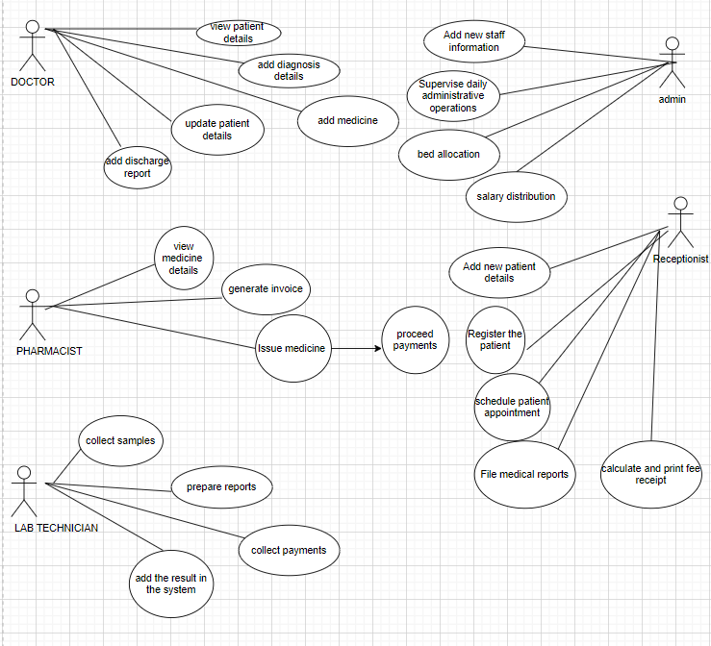

**E-R DIAGRAM**

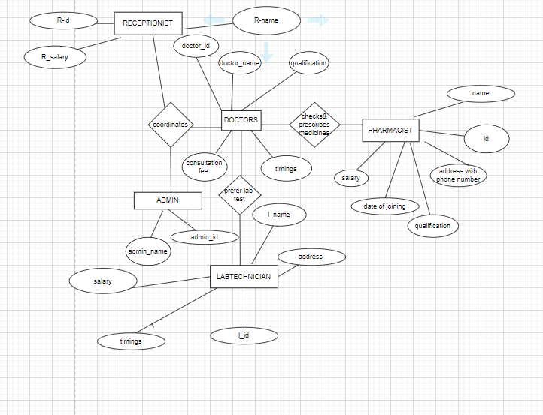

**DATABASE DESIGN**

**EMPLOYEE TABLE**

| FIELDS | DATA TYPE | RELATIONSHIP |
| --- | --- | --- |
| EmployeeId | Int | pk |
| EmployeeName | varchar | Not Null |
| Department | varchar | Not Null |
| PhoneNumber | Varchar | Not Null |
| UserName | Varchar | Not Null |
| Password | Varchar | Not Null |
| RoleName | Varchar | Not Null |

**EmployeeTable**

| Emplyoyee_id(pk) | Name | department | Phone | UserName | Password | RoleName |
| --- | --- | --- | --- | --- | --- | --- |
| 1001 | Dr [Binu Christin](mailto:binu.christin@faithinfotech.in) | Ophthalmologist | 8978632434 | binu@123 | 1234 | Doctor |
| 1002 | Dr Sajitha | Cardiologist | 9078783244 |  |  |  |
| 1003 | Dr Leema | Skin specialist | 7867328922 | 01 |  |  |
| 1004 | Diana | Front office | 9900434565 | 03 |  |  |
| 1005 | Sreejith | Pharmacy | 7889789432 | 05 |  |  |
| 1006 | Dhanya | Lab assistant | 9847126874 | 06 |  |  |

| PatientId | PatientName | Age | Gender | Address | PhoneNumber |
| --- | --- | --- | --- | --- | --- |
| 101 | Dona | 18 | F | Kollam | 7896783344 |
| 102 | Rima | 36 | F | Karyavattom | 8986757873 |
| 103 | Praveena | 18 | F | sreekaryam | 7889438953 |
|  |  |  |  |  |  |
|  |  |  |  |  |  |
|  |  |  |  |  |  |

**PATIENT TABLE**

| FIELDS | DATA TYPE | RELATIONSHIP |
| --- | --- | --- |
| PatientId | int | Primary Key |
| PatientName | varchar(20) | Not null |
| Age | int | Not null |
| Gender | varchar(10) | Not null |
| Address | varchar(50) | Not null |
| PhoneNumber | varchar(10) | Not null |

**MEDICINE TABLE**

| FIELDS | DATA TYPE | RELATIONSHIP |
| --- | --- | --- |
| MedicineId | int | Primary Key |
| MedicineName | varchar(50) | Not null |
| Brand | varchar(50) | Not null |
| Description | varchar(40) | Not null |
| DateOfExpiry | date | Not null |
| MedicineFee | decimal(10,2) | Not null |

| MedicineId | MedicineName | Brand | Description | DateOfExpiry | Price |
| --- | --- | --- | --- | --- | --- |
| 1 | Crocin | Crocin | paracetamol | 15-01-2023 | 10 |
| 2 | Dolo650 | Dolo | paracetamol | 23-02-2022 | 20 |
| 3 | Dart | Dart | Paracetamol & caffeine | 15-03-2023 | 16 |

**PRESCRIPTION TABLE**

| FIELDS | DATA TYPE | RELATIONSHIP |
| --- | --- | --- |
| PrescriptionId | int | Primary Key |
| PrescriptionDate | date | Not null |
| DoctorId | int | FOREIGN KEY REFERENCES employee(employeeid) |
| PatientId | int | FOREIGN KEY REFERENCES Patient(Patientid) |

| PrescriptionId | PrescriptionDate | DoctorId | PatientId |
| --- | --- | --- | --- |
| 01 | 08-01-2022 | 1002 | 103 |
| 02 | 10-01-2022 | 1002 | 103 |
| 03 | 10-01-2022 | 1002 | 102 |
| 04 | 10-01-2022 | 1003 | 102 |

**MEDICINE PRESCRIPTION TABLE**

| FIELDS | DATA TYPE | RELATIONSHIP |
| --- | --- | --- |
| PrescriptionMedId | varchar(10) | Primary Key |
| PrescriptionId | varchar(10) | Foreign Key REFERENCE Prescription (prescription_id) |
| MedicineId | varchar(10) | Foreign Key REFERENCES Medicine (medicine_id) |
| Dosage | varchar(20) | Not null |

| PrescriptionMedId | PrescriptionId | MedicineId | Dosage |
| --- | --- | --- | --- |
| P01 | 01 | 1 | 0-1-1 |
| P02 | 02 | 1 | 0-1-0 |
| P03 | 02 | 2 | 1-0-1 |
| P04 | 03 | 1 | 1-0-0 |
| P05 | 03 | 3 | 0-0-1 |

**Lab Test Category Table**

| FIELDS | DATA TYPE | RELATIONSHIP |
| --- | --- | --- |
| TestCategoryId | varchar(10) | Primary key |
| CategoryType | varchar(10) | Not null |
| ValueRange | varchar(20) | Not null |
| TestName | varchar(20) | Not null |
| LabFee | Long int | Not null |

| TestCategoryId | CategoryType | ValueRange | TestName | LabFee |
| --- | --- | --- | --- | --- |
| 1111 | Platelet count | 10-12 normal  > 12 high  <10 low | Blood test | 100 |
| 1112 | LDL | 150-170 normal  >170 High  <150 low | Lipid Profile | 50 |
| 1113 | triglycerides | 100-110 normal  >110 High  <100 low | Lipid Profile | 60 |

**LAB ADVICE TABLE**

| FIELDS | DATA TYPE | RELATIONSHIP |
| --- | --- | --- |
| TestCategoryId | Int | Not null, FOREIGN KEY REFERENCES LabTestCategory(TestCategoryId) |
| PrescriptionId | Int | Not null,Foreign Key REFERENCE Prescription (prescription_id) |
| TestDate | datetime | Not null |
| DoctorId | Int | Not null, FOREIGN KEY REFERENCES employee(employeeid) |
| PatientId | Int | Not null,FOREIGN KEY REFERENCES Patient(Patientid) |

| LabId | TestId | PrescriptionId | TestDate | DoctorId | PatientId |
| --- | --- | --- | --- | --- | --- |
| L01 | T501 | 01 | 10-01-2022 | 1002 | 103 |
| L02 | T502 | 01 | 10-01-2022 | 1002 | 103 |
| L03 | T501 | 04 | 10-01-2022 | 1003 | 102 |
| L04 | T503 | 04 | 10-01-2022 | 1003 | 102 |
| L05 | T504 | 04 | 10-01-2022 | 1003 | 102 |
| L06 | T505 | 04 | 10-01-2022 | 1003 | 102 |

**APPOINTMENT TABLE**

| FIELDS | DATA TYPE | RELATIONSHIP |
| --- | --- | --- |
| AppointmentId | Int | Primary key |
| PatientId | Int | Not null,FOREIGN KEY REFERENCES Patient(Patientid) |
| DoctorId | Int | FOREIGN KEY REFERENCES employee(employeeid) |
| AppointmentDate | date\time | Not null |
| AppointmentFee | int | Not null |

| AppointmentId | PatientId | DoctorId | AppointmentDateTime | AppointmentFee |
| --- | --- | --- | --- | --- |
| A01 | 102 | 1002 | 08-01-2022 | 150 |
| A02 | 103 | 1003 | 10-01-2022 | 150 |

**BILL TABLE**

| FIELDS | DATA TYPE | RELATIONSHIP |
| --- | --- | --- |
| BillId | varchar(10) | Primary key |
| PatientId | varchar(10) | FOREIGN KEY REFERENCES Patient(Patientid) |
| MedicineFee | Decimal(10,2) | Not Null |
| LabFee | Long int | Not Null |

| BillId | PatientId | MedicineCharge | LabCharge |
| --- | --- | --- | --- |
| B200 | 101 | 250 | 450 |
|  |  |  |  |